Gourd Springs Baptist Church Preschool

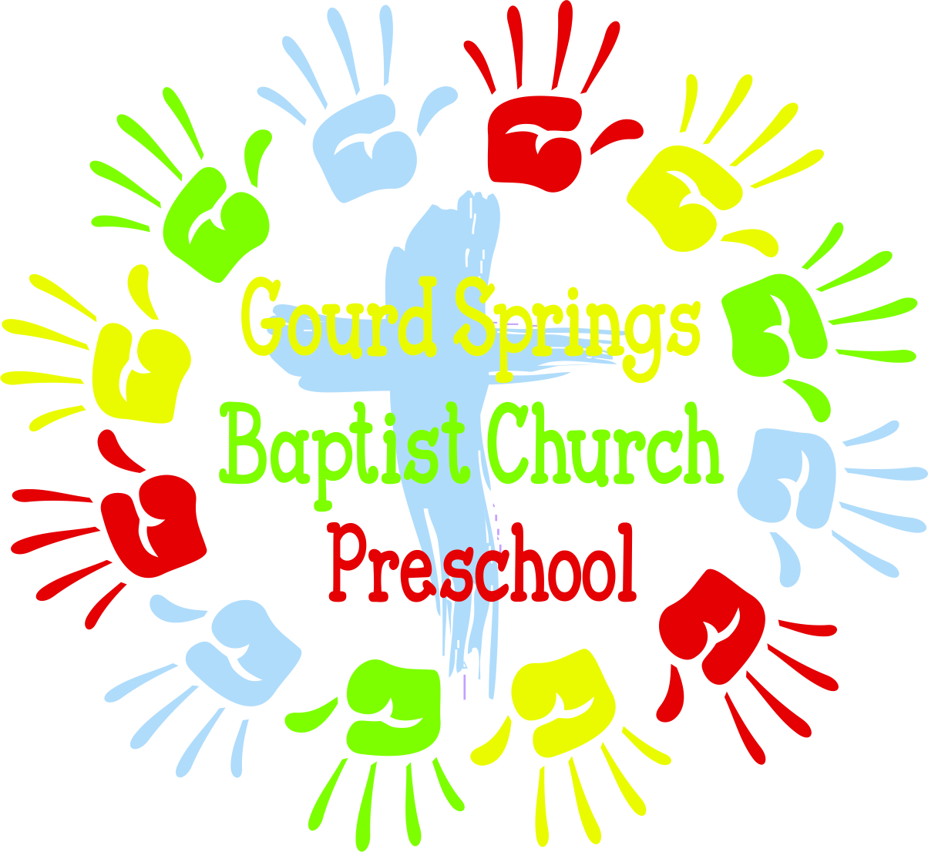

2023-2024
Parent Handbook

Gourd Springs Baptist Church
4575 Ray Road
Spring Lake, NC 28390
910-436-0276
www.gourdsprings.com
gsbcpreschool@gmail.com

Updated 7/13/23

Mission

Gourd Springs Baptist Church Preschool was established as an outreach to the community to provide a quality early education experience for children ages 3 through kindergarten that will nurture our children spiritually, academically, and socially in a warm, friendly environment within a spiritual setting.
Admission
GSBC Preschool admits students of any race, color, national origin or ethnicity to all the privileges, rights, programs and activities provided by this school.
Please note: The school is not able to accept children with severe learning or physical disabilities or infectious diseases as we do not have adequate facilities or staff to accommodate.
A completed application should be turned in along with the registration fee to secure a slot for your child. If all spots are filled then your child will be placed on the waiting list.
A completed medical information/physical form and immunization record is due by September 30th of each year.
Philosophy
Our school is designed to start the education process of learning to work with others, to respect others and their feelings. Also, children will be developing the skills of shapes, sizes, letter and number identification to better prepare them for kindergarten. They will do this by learning through songs, games, arts and crafts and center rotations.
Each staff member is qualified and competent to provide loving and nurturing care to each child. Our teacher/child ratio is in accordance with the state law: twelve or less per teacher. Classes are divided according to each child’s age.
All children must be potty trained.
Must be 3 by Sept 1.
Programs
GSBC Preschool offers programs that are designed for children ages 3 through kindergarten. Classroom assignments are based on the child's date of birth.
Hours: Monday through Friday from 9:00am to 12:30 pm
The preschool year will begin the first Tuesday in September following Labor Day and will end the last Thursday in May before Memorial Day.
A calendar will be given at the beginning of the school year with dates for holidays, teacher workdays and early dismissal days.

Inclement Weather Closings/Delays
The decision will be made and sent to parents via Class Tag app.
Curriculum
We use the ABEKA curriculum for our Bible and Music portion of the program.

Daily Program Schedule:
Carpet Time: flag salute, calendar, song and story
Class/Table Top Time: daily lesson by curriculum but to include color, shape, and letter and number concepts
Snack Time
Center/Activity Time: rotation of centers
Play Time: indoor or outdoor depending on weather
Resource Time: weekly rotation of music, science, character education, bible story, arts/crafts

Drop Off/Pick up Policies
School begins at 9:00am. We will be ready to greet your child at 8:55 am.
Pick up time is 12:30 pm. After 12:45pm a $5.00 late charge will be payable to the teacher; plus $1.00 per minute thereafter.
Children will only be released to the parent or guardian or other authorized persons listed on your child’s information sheet. Please notify your child’s teacher in writing if someone other than those listed will be picking up your child. In the event of an emergency, please call the church office to notify the school of who will be picking up your child. To ensure the safety of your child, presentation of photo ID will be required/car rider tag to be displayed in the vehicle.

Tuition Policies:
We strive to give your child the best quality, consistent care for an early education. Our expenses are ongoing even when your child is absent from school. Therefore, we ask that you comply with the tuition policy.
Registration Fee: $50.00 per child per year. Due upon enrollment. This is nonrefundable.
Tuition Fee: $300.00 per month for non-church members, $250.00 for each sibling and/or $275.00 per month for Gourd Springs Church members. (Updated 2-7-19)
Tuition is due the first day of school each month. Late fee of $25.00 will be due for late payment if received after the first week. There is no refund or credit for days absent, inclement weather or days when school is closed.
Payments can be made by check or cash. Make checks payable to GSBC Preschool. Place payment in an envelope with your child’s name, teacher name and amount. Payments can be dropped off in the payment box by the church office or your child’s daily take home folder. Receipts available by request.
NOTE: We are a Preschool not a Daycare so there is no Tax Break.
Withdrawal Policy:
To withdraw your child please inform your child’s teacher at least 2 weeks in advance. No refund on tuition.
Your child will automatically be withdrawn if your account is 30 days past due or if an extended absence occurs without informing your child’s teacher.
Snack:
We provide a nutritious snack each school day. Please let us know if your child has any food allergy

Health Information:
Children’s Medical Report: Please note that each child is required to have a physical at the beginning of each school year signed by a licensed physician. It is due with an up-to-date immunization record within 30 days of the start of school.
In Case Your Child is Ill:
Children that are obviously ill upon arrival will not be allowed to stay. Children who become ill will be isolated and parents will be notified to pick them up as soon as possible. We realize that all illnesses cannot be prevented, and during the preschool years many children are exposed to communicable diseases. However, we have a responsibility to each child in school and feel that if good health and hygiene are followed the spread of many of these diseases can be kept at a minimum. We use many measures to clean, disinfect and sanitize all classrooms and toys/learning objects. We offer many times of handwashing during the day along with sanitizer if needed. Parents can help us keep the spread of sickness in the school at a minimum by following the guidelines below on when to keep your child home from school if they are showing signs of sickness.
Parents can help us with this by teaching your child good hygiene measures like washing hands with soap and water for 20 seconds (Sing Twinkle Twinkle Little Star or Happy Birthday song x 2). Teaching your child to cover their cough/ sneeze in their elbow. Teaching your child that their fingers should not go in their nose. And keeping their hands off their face/eyes.
Please do not bring your child if he/she:
-Has a fever of 99 or higher. Must be fever free with no meds for 24 hrs.
-Has been vomiting or had diarrhea within the last 24 hours. Must be vomiting or diarrhea free for 24hrs.
-Has matted, yellowish discharge from eyes or has pink eye
-Has a fresh cold (Colored drainage from nose) deep cough, or sore throat
-Has a communicable disease such as mumps, measles, chickenpox, strep throat, impetigo, flu, roseola, hand foot mouth disease

First Aid:
When children are at play, scratches and bumps can happen. Such injuries will be cleaned and treated. In the event of a more serious incident, you will be notified

